
2019 Veteran’s Town Hall & Resource Fair

All Military/Veterans/National Guard and Families are Welcome!
Location: Starkville Sportsplex, 405 Lynn Ln, Starkville, MS
When: October 8, 2019 @ 1 – 4 p.m.

Connect with your fellow Vets. Get to know local Veteran Service organizations.

- Establish eligibility for state veterans benefits (bring your DD form 214)
- Get help obtaining military medals and records
- Obtain information about nursing home care and burial benefits
- Learn about the wide range of benefits available including: health care enrollment, long-term care, disability, education, funeral honors and more! Also enjoy a pedicure, a manicure, hair trim or a foot soak compliments of a local business and local School of Cosmetology. There will also be free Diabetes screenings.
- Obtain assistance for those experiencing homelessness

Scheduled to attend:
Organizations & Resources:

●American Legion and VFW
●County Veteran Service Officers
●Citizens Soldier For Life
●Department of Veterans Affairs: Representatives to assist with federal benefits
●EMCC School of Cosmetology (free haircuts, manicures or pedicures)
●EMCC Workforce Training
●Equal Employment Opportunity
●ESGR (Employer Support of the Guard & Reserve)
●Golden Triangle Planning & Development (Council of Aged)
●Gulf Coast Veteran Advocacy
●Humana
●Jackson Vet Center
●Job Corps
●Lions Club (free eye tests)
●MOPH (Purple Heart)
●MS Kidney Foundation
●MSU Sonny Montgomery Center For America’s Veterans
●MSU VBOC (Veterans Business Outreach Center)
●MS Veterans Health Care System
●MS Veterans Homes and State Veterans Cemeteries
●MS Vocational Rehabilitation
●MS Veterans Commission: Counselors to assist with disability and pension claims, employment services and educational benefits
●MUTEH (Mississippians United to End Homelessness)
●OCH
●OSERVs
●Salvation Army
●Social Security
●USAA
●VA Outpatient Clinic
●Veterans Comprehensive Resource Center
●Veterans Golf Association

AND MORE…

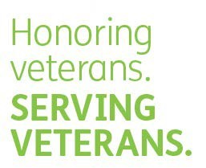

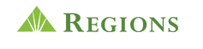

For information contact Sharon Dollarhide / sdollarhide@msva.ms.gov (662) 325-6867

