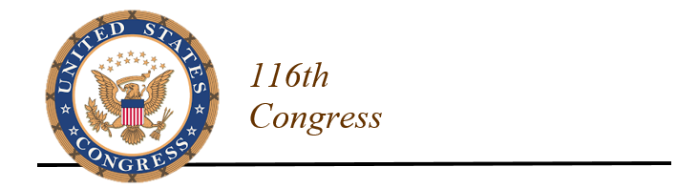
FOR IMMEDIATE RELEASE  November 6, 2019 | CONTACTS  Rick VanMeter (Wicker) 202-224-6253  Chris Gallegos (Hyde-Smith) 202-224-6414  Susan Parker (Kelly) 662-841-8808  Rob Pillow (Guest) 202-981-3165

MISS. LAWMAKERS PRESS FISH & WILDLIFE SERVICE TO ADDRESS AVIAN PREDATORS DAMAGE TO LIVESTOCK, AQUACULTURE PRODUCTION

Wicker, Hyde-Smith, Kelly & Guest Sign Bicameral Letter Urging Agency to Ease Regulatory Burden on Farmers

WASHINGTON, D.C. – U.S. Senators Roger Wicker (R-Miss.) and Cindy Hyde-Smith (R-Miss.) and Representatives Trent Kelly (R-Miss.) and Michael Guest (R-Miss.) today encouraged the U.S. Fish and Wildlife Service (FWS) to rewrite the federal rules that limit the ability of livestock producers and catfish farmers to fight losses due to predatory birds.

The Mississippi lawmakers signed a bicameral letter that asks the FWS to give livestock and aquaculture producers greater flexibility in protecting their animals from avian predators shielded under the Migratory Bird Treaty Act (MBTA). The lawmakers seek to replace an inadequate permitting structure with a more streamlined process.

“We recognize there are federal processes in place for affected producers to manage protected avian predators. However, these processes are often insufficient to adequately address the problem,” the lawmakers wrote. “We urge the FWS to promulgate new rules that simplify and streamline the permitting process, as well as allow greater flexibility for livestock and aquaculture producers to protect their livelihoods from these avian predators.”

Double-crested cormorants, black vultures, and ravens are among the predatory birds protected by the MBTA that inflict serious harm on livestock and fish operations. The U.S. Department of Agriculture (USDA) estimates double-crested cormorants cause more than $25 million in damage annually for the catfish and aquaculture industry. USDA also reported that black vultures are responsible for 10 percent of all calves lost to predators.

“With populations of each species numbering well in the millions, they are thriving and face no immediate or foreseeable threat of extinction. It is incumbent upon the FWS to consider the growing economic losses inflicted upon livestock and aquaculture producers by these birds,” the lawmakers said.

Under the current FWS permitting process, farmers must apply annually and pay a fee to obtain a permit to use certain methods to protect their animals from predatory birds. These permits cap an applicant’s legal take, often at levels inadequate to prevent loss or deter further predation.

U.S. Senator John Boozman (R-Ark.) and U.S. Representative Sanford D. Bishop, Jr. (D-Ga.) led the letter, which was signed by Senators and Representatives from Mississippi, Alabama, Arkansas, Tennessee, Missouri, Kentucky, Georgia, South Carolina, Ohio, Oklahoma, Idaho, and Wyoming.

The letter to FWS Deputy Director Margaret Everson is available here.

###

